Name – **Onkar Kajrolkar**

CampbuzzId – **2020Sep@03308**

Email – **onkarkajrolkar7798@gmail.com**

**Web Based Case Study**

**LBJ Cycle-2**

1. **Synopsis –**

Web Development has been an increasing technology with engineers mastering the skills of frontend as well as backend. This Case study gave us the opportunity to experience the tip of the iceberg that is Web Development. The Frontend for this case study was built with HTML5 for web pages and CSS for styling of the said web pages. The server side code was written using Python by implementing the Flask module for setting up a local server. The HTML5 web pages are stored in the “templates” folder and the CSS styling file is stored in the “static” folder. The Flask will search for the templates and static folders for rendering the webpages and styling files respectively. Using python and the data received through the web pages, we can write to/read from a CSV file.

1. **Source Code –**
2. **“~/students-server.py” –**
3. from flask import *
4. import csv
5. keys = ['Student ID', 'Student Name', 'Gender', 'Date of Birth', 'City', 'State', 'Email ID', 'Qualification', 'Stream']
6. app = Flask(__name__)
7. app.secret_key = "wubbalubbadubdub"
8. @app.route("/")
9. def index():
10. return render_template("index.html")
11. @app.route("/add", methods=["POST", "GET"])
12. def add():
13. if request.method == "POST":
14. result = list(request.form.values());
15. split = result[3].split('-')
16. result[3] = split[2]+"-"+split[1]+"-"+split[0]
17. with open('students.csv', 'a', newline='\n') as csv_file:
18. csv_writer = csv.writer(csv_file)
19. csv_writer.writerow(result)
20. flash("Student added to the Database!")
21. return render_template("add-student.html")
22. @app.route("/search", methods=["POST", "GET"])
23. def search():
24. if request.method == "POST":
25. id = list(request.form.values())
26. print(id[0])
27. success = False
28. with open('students.csv', 'r') as csv_file:
29. csv_reader = csv.reader(csv_file)
30. for line in csv_reader:
31. if line[0] == id[0]:
32. details = line
33. success = True
34. if not success:
35. if id[0] == '':
36. flash("Please Enter ID", "info")
37. else:
38. flash(f"Student ID: {id[0]} not found, Please try again!", "info")
39. else:
40. result = dict(zip(keys, details))
41. return render_template("search-student.html", data=True, result=result)
42. return render_template("search-student.html", data=False, result="")
43. @app.route("/display")
44. def display():
45. with open('students.csv', 'r') as csv_file:
46. csv_reader = csv.reader(csv_file)
47. return render_template("display-student.html", result=csv_reader, keys=keys)
48. if __name__=="__main__":
49. app.run()
50. **“~/templates/index.html” –**
51. <!DOCTYPE html>
52. <html>
53. <link rel="stylesheet" type="text/css" href="{{ url_for('static', filename='style.css')}}">
54. <head>
55. <title>Student Dashboard</title>
56. </head>
57. <body>
58. <ul id="list" type="none" align="center">
59. <li><button class="button" onclick="window.location='add'">Add Student</button></li>
60. <li><button class="button" onclick="window.location='search'">Search Student</button></li>
61. <li><button class="button" onclick="window.location='display'">Display all Students</button></li>
62. </ul>
63. </body>
64. </html>
65. **“~/templates/add-student.html”**
66. <!DOCTYPE html>
67. <html>
68. <link rel="stylesheet" type="text/css" href="{{ url_for('static', filename='style.css')}}">
69. <head>
70. <title>Add A Student</title>
71. </head>
72. <body>
73. <div id="entry" align="left">
74. <ul type="none">
75. <form action="" method="post">
76. <li>Student Id</li>
77. <li><input type="text" name="id" required></li>
78. <li>Student Name</li>
79. <li><input type="text" name="name" required></li>
80. <li>Gender</li>
81. <li><input type="radio" name="gender" value="Male" required>Male</li>
82. <li><input type="radio" name="gender" value="Female" required>Female</li>
83. <li>Date of Birth</li>
84. <li><input type="date" name="date" required></li>
85. <li>City</li>
86. <li><input type="text" name="city" required></li>
87. <li>State</li>
88. <li><input type="text" name="state" required></li>
89. <li>Email Id</li>
90. <li><input type="text" name="email" required></li>
91. <li>Qualification</li>
92. <li><input type="text" name="qual" required></li>
93. <li>Stream</li>
94. <li><input type="text" name="stream" required></li>
95. <li><input type="submit" class="submit" value="Submit"></li>
96. </form>
97. {% with messages = get_flashed_messages() %}
98. {% if messages %}
99. {% for message in messages %}
100. <li>{{messages}}</li>
101. {% endfor %}
102. {% endif %}
103. {% endwith %}
104. <li><button class="submit" onclick="window.location='/'">Home</button></li>
105. </ul>
106. </div>
107. </body>
108. </html>
109. **“~/templates/search-student.html” –**
110. <head>
111. <title>Search Student by College Id</title>
112. </head>
113. <body>
114. <div class="search" align="center">
115. <form action="" method="post">
116. <p style="font-family:sans-serif">Student ID</p>
117. <input type="text" name="id"><br>
118. <input type="submit" class="submit" name="Submit">
119. </form>
120. {% with messages = get_flashed_messages() %}
121. {% if messages %}
122. {% for message in messages %}
123. <p>{{messages}}</p>
124. {% endfor %}
125. {% endif %}
126. {% endwith %}
127. {% if data %}
128. {% for key,value in result.items() %}
129. <table class="table-search" >
130. <tr>
131. <th>{{key}}</th>
132. <td>{{value}}</td>
133. </tr>
134. </table>
135. {% endfor %}
136. {% endif %}
137. <button class="submit" onclick="window.location='/'">Home</button>
138. </div>
139. </body>
140. </html>
141. **“~/templates/display-student.html” –**
142. <!DOCTYPE html>
143. <html>
144. <link rel="stylesheet" type="text/css" href="{{ url_for('static', filename='style.css')}}">
145. <head>
146. <title>Display all Students</title>
147. </head>
148. <body>
149. <div id="list" align="center">
150. <table class="table-display" border="1">
151. <tr>
152. {% for i in keys %}
153. <th>{{i}}</th>
154. {% endfor %}
155. </tr>
156. {% for lines in result %}
157. <tr>
158. {% for value in lines %}
159. <td>{{value}}</td>
160. {% endfor %}
161. </tr>
162. {% endfor %}
163. </table>
164. <button class="submit" onclick="window.location='/'">Home</button>
165. </div>
166. </body>
167. </html>
168. **“~/static/style.css” –**

body{

background: #007fff;

}

#list{

background: #e6e6e6;

color: white;

font-family: sans-serif;

align-self: center;

width: 1000px;

margin: 100px auto;

border-radius: 10px;

box-shadow: 0 0 20px rgba(0,0,0,2);

}

.button{

background: white;

color: black;

font-family: 'Nunito',sans-serif;

font-size: 200%;

margin: 50px 20px;

padding: 10px;

text-align: center;

position: relative;

border-radius: 10px;

box-shadow: 0 0 5px rgba(0,0,0,0.5);

}

.button:hover,.submit:hover{

background: #004dff;

color: white;

cursor: pointer;

}

#entry{

font-family: sans-serif;

background: #e6e6e6;

color: black;

width: 300px;

align-self: center;

margin: 100px auto;

padding: 10px;

border-radius: 10px;

box-shadow: 0 0 20px rgba(0,0,0,2);

}

.submit{

background: white;

color: black;

font-family: 'Nunito',sans-serif;

font-size: 100%;

margin: 10px 50px;

padding: 10px;

text-align: center;

position: relative;

border-radius: 10px;

box-shadow: 0 0 5px rgba(0,0,0,0.5);

}

.search{

font-family: sans-serif;

background: #e6e6e6;

color: black;

padding: 20px;

width: 500px;

margin: 100px auto;

border-radius: 10px;

box-shadow: 0 0 20px rgba(0,0,0,2);

}

.table-search{

width: 400px;

overflow: hidden;

}

.table-search th{

background-color: #007fff;

color: white;

text-align: left;

font-weight: bold;

}

.table-search th,.table-search td{

padding: 12px 15px;

width:16.6%;

word-break: break-all;

border: 1px solid black;

}

.table-search tbody tr{

border-bottom: 1px solid #e6e6e6;

}

.table-search tbody tr:last-of-type {

border-bottom: 2px solid #007fff;

}

.table-display{

border-collapse: collapse;

color: black;

margin: 25px 0;

font-size: 90%;

min-width: 400px;

border-radius: 10px 10px 0 0;

overflow: hidden;

box-shadow: 0 0 20px rgba(0, 0, 0, 0.15);

}

.table-display th{

background-color: #007fff;

color: #ffffff;

text-align: left;

font-weight: bold;

}

.table-display th,

.table-display td {

padding: 12px 15px;

}

.table-display tbody tr {

border-bottom: 1px solid #dddddd;

}

.table-display tbody tr:nth-of-type(even) {

background-color: #f3f3f3;

}

.table-display tbody tr:last-of-type {

border-bottom: 5px solid #007fff;

}

1. **Approach –**

The approach towards this problem statement was fairly simple. First the basic templates for the web pages were created using HTML and the entry fields, buttons, forms, etc were added to the web pages. Styling for the web pages was done by using CSS file to make it more user-friendly. Then to make a local server on which these web pages will be rendered and the functionalities to be carried out, python was used. Python offers Flask module which is used to create a local server. The python code also governs the behaviour of the web pages. It carries out the functions on the backend. It sends/receives data to the client side as per the request generated by the client. The python file then depending on the request, reads and write data to the CSV file. The web pages form the face of the whole web application and the python code forms the main brain of the application.

1. **Coding Practices –**

Python offers Flask module which is used here to form a local server to render web pages. Flask is a lightweight WSGI (Web Server Gateway Interface) web application framework. It is designed to getting started quick and easy, with the ability to scale up to complex applications. The requirement for this particular application was basic so the Flask framework was chosen.

1. **Screenshots –**

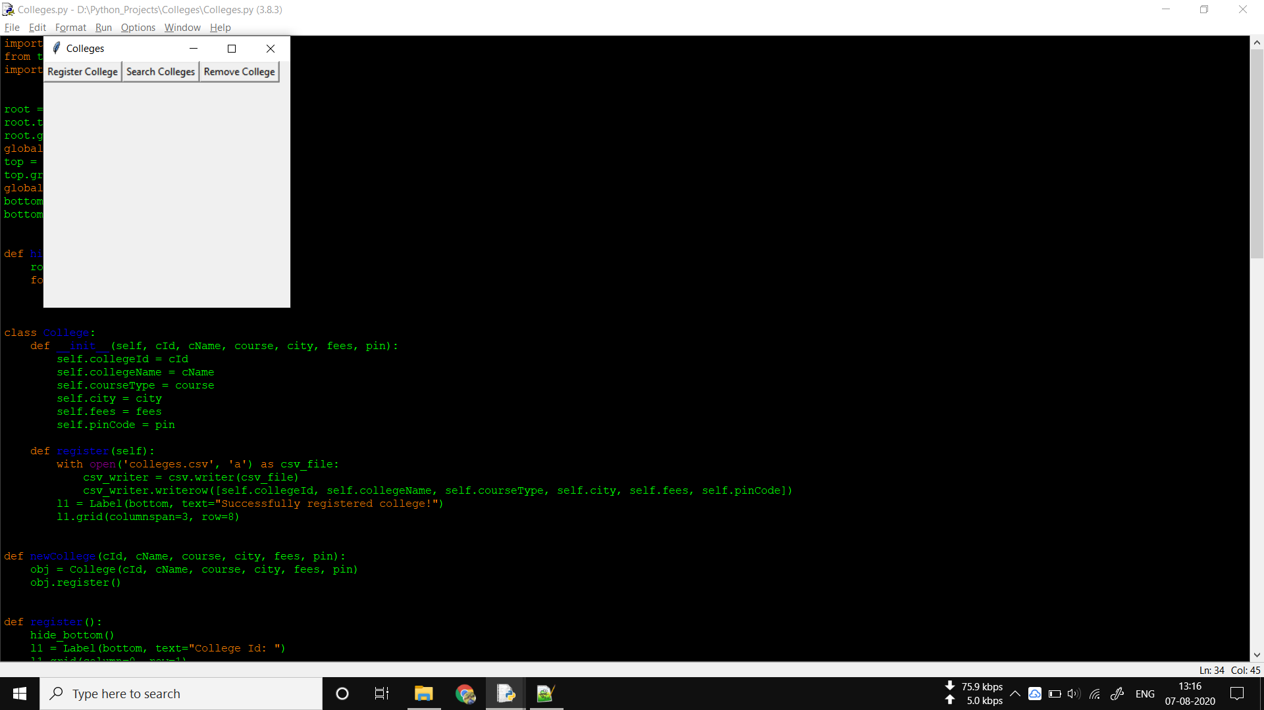

Fig1 – Options given to the user in the application

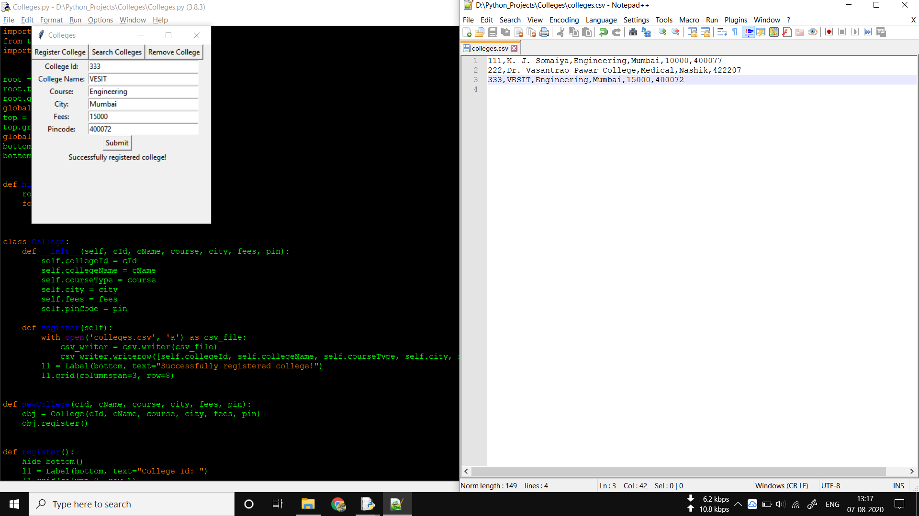

Fig2 – Registering a new College

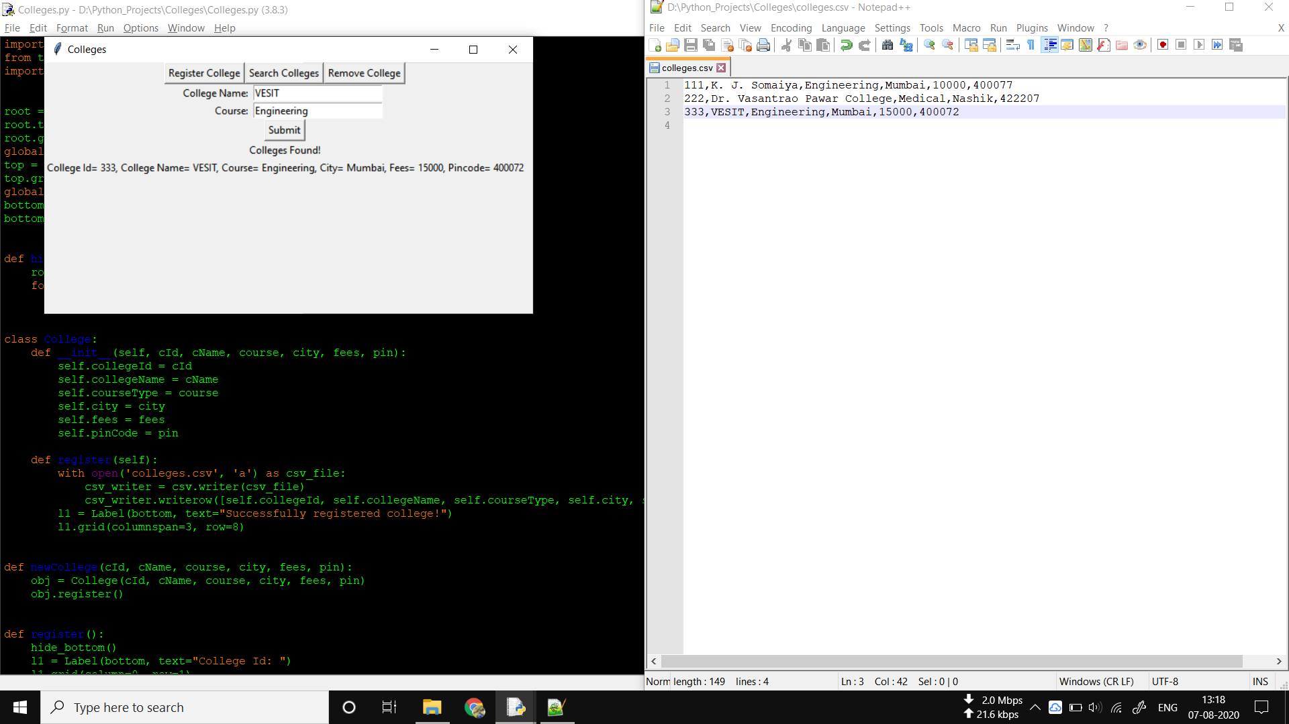

Fig3 – Searching a College

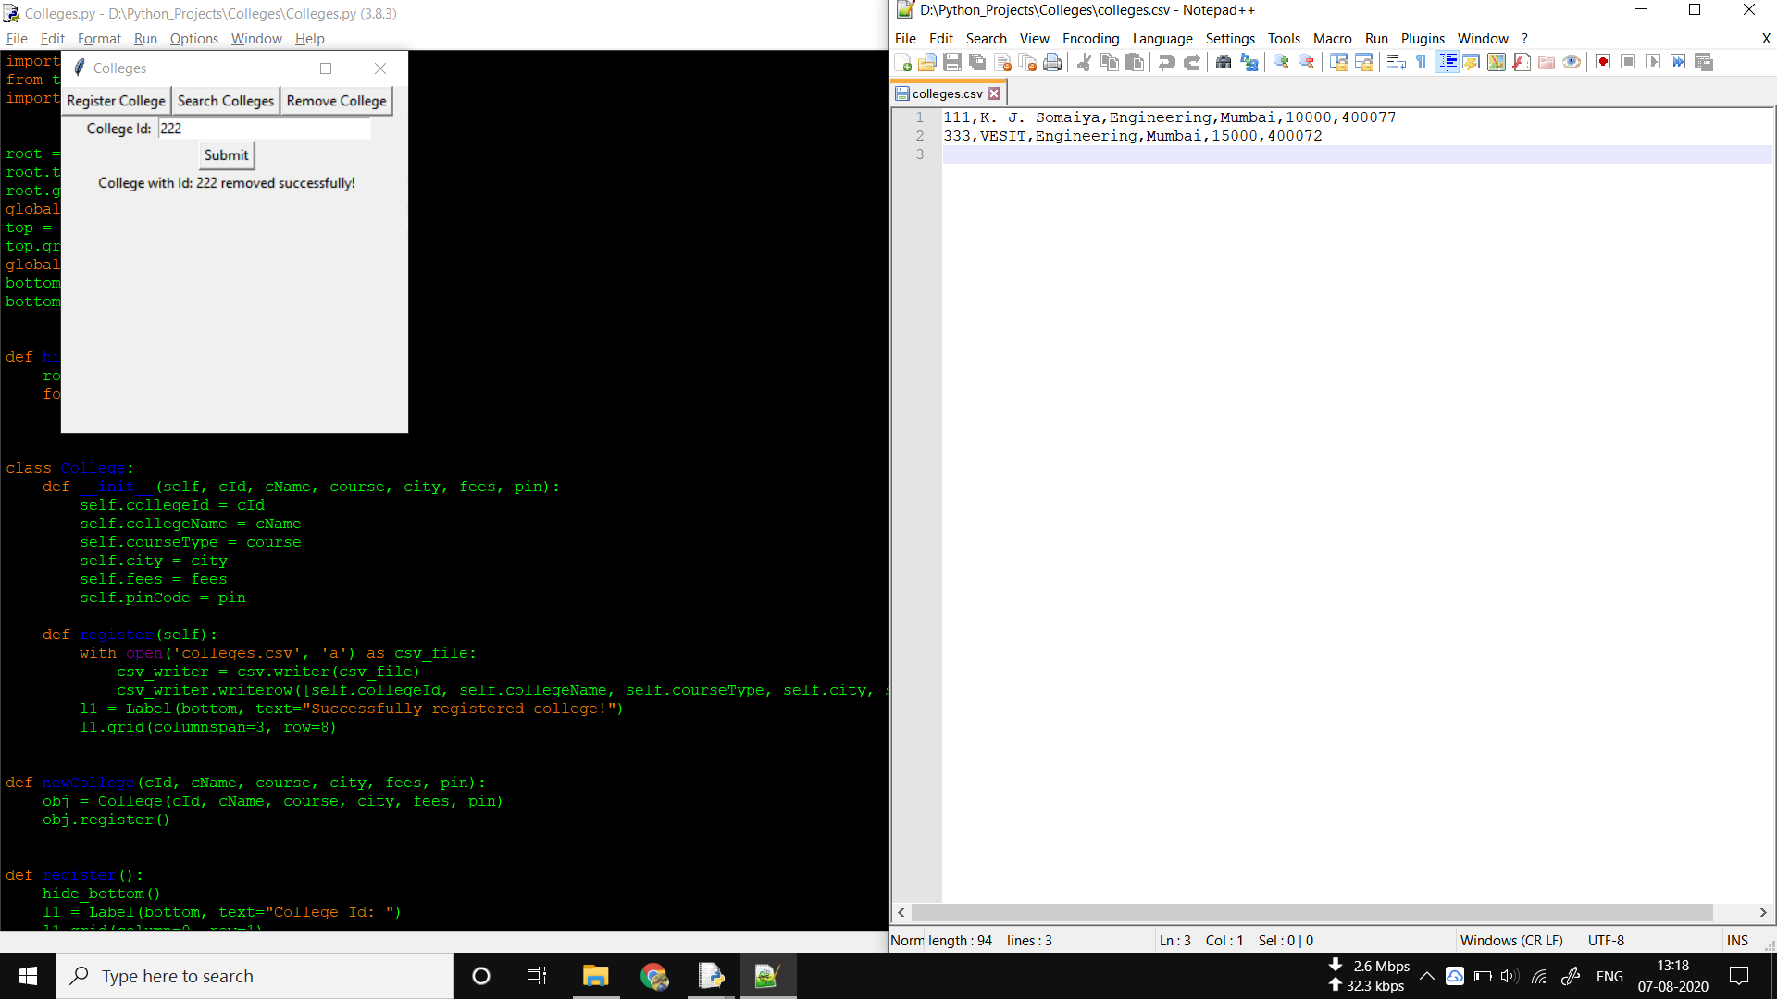

Fig4 – Removing a College